# INTERDISCIPLINARY PROJECT REPORT

**at**

**Sathyabama Institute of Science and Technology (Deemed to be University)**

Submitted in partial fulfillment of the requirements for the award of Bachelor of Engineering Degree in Computer Science and Engineering

By

## NAME-DILIP KUMAR YADAV

**(Reg.No.40110324)**



**DEPARTMENT OF COMPUTER SCIENCE AND ENGINEERING SCHOOL OF COMPUTING**

**SATHYABAMA INSTITUTE OF SCIENCE AND TECHNOLOGY JEPPIAAR NAGAR, RAJIV GANDHI SALAI,**

**CHENNAI – 600119, TAMILNADU**

**APRIL 2023**



**SATHYABAMA**

**INSTITUTE OF SCIENCE AND TECHNOLOGY**

### (DEEMED TO BE UNIVERSITY)

**Accredited with Grade “A” by NAAC**

**(Established under Section 3 of UGC Act, 1956)**

**JEPPIAAR NAGAR, RAJIV GANDHI SALAI, CHENNAI– 600119**

[**www.sathyabamauniversity.ac.in**](http://www.sathyabamauniversity.ac.in/)

# DEPARTMENT OF COMPUTER SCIENCE AND ENGINEERING

**BONAFIDE CERTIFICATE**

This is to certify that this Project Report is the bonafide work of **DILIP KUMAR YADAV(40110324)** who carried out the project entitled “**BOOK RECOMMENDATION USING COLLABORATIVE FILTERING**” under my supervision from FEB 2023 to APRIL 2023.

## Internal Guide

## Name

**Head of the Department**



## Submitted for Viva voce Examination held on

**InternalExaminer ExternalExaminer**

**DECLARATION**

I, **DILIP KUMAR YADAV**  hereby declare that the project report entitled **Book recommendation system using collaborative filtering** done by me under the guidance of **Dr.T Prem Jacob M.E., Ph.D** is submitted in partial fulfillment of the requirements for the award of Bachelor of Engineering Degree in Computer Science and Engineering.

**ACKNOWLEDGEMENT**

I am pleased to acknowledge my sincere thanks to **Board of Management** of **SATHYABAMA** for their kind encouragement in doing this project and for completing it successfully. I am grateful to them.

I convey my thanks to **Dr. T.Sasikala M.E., Ph.D.**, **Dean**, School of Computing , **Dr.S.Vigneshwari M.E., Ph.D., and Dr.L.Lakshmanan M.E., Ph.D.,** Heads of the Department of Computer Science and Engineering for providing me necessary support and details at the right time during the progressive reviews.

I would like to express my sincere and deep sense of gratitude to my Project Guide **Dr.T Prem Jacob** for his valuable guidance, suggestions andconstantencouragementpavedwayforthesuccessfulcompletionofmyprojectwork.

I wish to express my thanks to all Teaching and Non-teaching staff membersofthe**DepartmentofComputerScienceandEngineering** who werehelpful in many ways for the completion of theproject.

**TRAINING CERTIFICATE**

# ABSTRACT

Now-a-days, everyone depending on reviews by others in many things such as selecting a movie to watch, buying products, reading a book. Recommender systems are used for that purpose only. A recommender system is a kind of filtering system that predicts a user's rating of an item.

Recommender systems recommend items to users by filtering through a large database of information using a ranked list of predicted ratings of items. Online Book recommender system is a recommender system for ones who love books. When selecting a book to read, individuals read and rely on the book ratings and reviews that previous users have written. In this paper, Hybrid Recommender system is used in which Collaborative Filtering and PopularityBased Filtering techniques are used. The author used Collaborative techniques such as Clustering in which data-points are grouped into clusters.

Algorithms such as Kmeans clustering are used for clustering. The better algorithm was selected with the help of silhouette score and used for clustering. Matrix Factorization technique such as Truncated-SVD which takes sparse matrix as input is used for reducing the features of a dataset. Content Based Filtering System used TFIDF vectorizer which took statements as input and return a matrix of vectors. RMSE (Root Mean Square Error) is used for finding the deviation of an absolute value from an obtained value and that value is used for finding the fundamental accuracy. Keywords: Book Recommender System, Matrix Factorization,Clustering,K-Means.

**TABLE OF CONTENTS**

**CHAPTER No. TITLE Page no**

ABSTRACT

LIST OF FIGURES

**1 INTRODUCTION**

1.1 Introduction 1

1.2 Machine Learning Basics 3

1.2.1 Importance of Machine Learning 4

1.2.2 Application of Machine Learning 5

1.2.3 Requirement for good machine learning system 5

1.3 Common Machine Learning algorithm and goals 6

1.4 Algorithms 7

1.4.1 Linear Regression 7

1.4.2 Naïve Baye’s 8

1.4.3 Logistic Regression 8

1.4.4 Decision Trees 9

1.4.5 Random Trees 10

1.4.6 K-Means Clustering 10

**2 AIM AND SCOPE OF THE PRESENT INVESTIGATION**

2.1 Aim 11

2.2Objective 11

2.3 Scope 11

**3 PROPSED METHODOLOGY**

3.1 Types of classification algorithm used15

3.2 Decision Tree Algorithm 15

3.3 Imported Libraries 16

3.4 Libraries Used 17

3.4.1 Pandas 17

3.4.2 Numpy 17

3.4.3 Sklearn 17

3.4.4 Autoviz 19

3.4.5 Matplotlib 20

3.5 Implementation of Decision Tree 21

**4** **RESULT, DISCUSSION AND PERFORMANCE ANALYSIS**

4.1 Training and accuracy (Model of Analysis) 22

4.1.1 Confusion Matrix 23

4.1.2 Accuracy 24

4.1.3 Precision 24

4.1.4 Recall 24

4.1.5 F1 Score 24

**5 SUMMARY AND CONCLUSION**

**REFRENCES 25**

**APPENDIX28**

A. WORKING ENVIROMENT 28

B. CODING ENVIROMENT 29

C.SCREENSHOTS 29

D.SOURCE CODE 33

# LIST OF FIGURES

## FIGURENO. FIGURENAME PAGENO.

1.1

1.2

2.1

3.1

# LIST OF TABLES

## TABLE NO.TABLENAME PAGENO.

1.1

1.2

2.1

3.1

# LIST OF ABBREVATIONS

ABBREVATION EXPANSION

**CHAPTER-1**

**INTRODUCTION**

**1.1 Introduction**

Now-a-days, online rating and reviews are playing an important role in books sales. Readers were buying books depend on the reviews and ratings by the others. Recommender system focuses on the reviews and ratings by the others and filters books. In this paper, Hybrid recommender system is used to boost our recommendations.

The technique used by recommender systems is Collaborative filtering. This technique filters information by collecting data from other users. Collaborative filtering systems apply the similarity index-based technique. The ratings of those items by the users who have rated both items determine the similarity of the items. The similarity of users is determined by the similarity of the ratings given by the users to an item. Content-based filtering uses the description of the items and gives recommendations which are similar to the description of the items. With these two filtering systems, books are recommended not only based on the user’s behaviour but also with the content of the books.

So, our recommendation system recommends books to the new users also. In this recommender system, books are recommended based on collaborative filtering technique and similar books are shown using popularity based filtering. The required dataset for the training and testing of our model is downloaded from Good-Reads website. Matrix Factorization technique such as Truncated-SVD which takes sparse matrix of dataset is used for reduction of features. The reduced dataset is used for clustering to build a recommendation system. Clustering is a collaborative filtering technique that is used to build our recommendation system in which data points are grouped into clusters.

In this paper, we used two methods i.e., K-means and Gaussian mixture for clustering the users. The better model is selected based on the silhouette score and used for clustering. Silhouette score or silhouette coefficient is used to calculate how good the clustering is done. Negative value shows that clustering is imperfect whereas positive value shows that clustering was done perfectly. Difference between the mean rating before clustering and after clustering is calculated. Root Mean square Error is used to measure the error between the absolute 2 values and obtained values. That RMSE value is used to find the fundamental accuracy.

**1.2 Machine Learning Basics**

Machine learning is a method of data analysis that automates analytical model building. It is a branch of AI (artificial intelligence) based on the idea that system can learn from data, identify patterns and make decisions with minimal human intervention

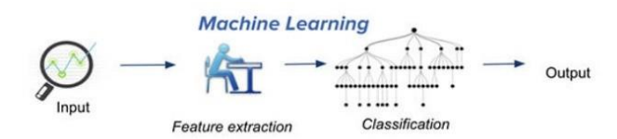

***Fig 1.1-Concept of Machine Learning***

Ever since the computer advances and other technological inventions made a progress in human life, we as people always wonder whether they might be made to learn. But we do not know how to make a computer to learn as nearly as people do. Today’s new machine learning is not like the one’s in the past.

They are based on pattern and along with the theory that computers can learn from data. The most crucial part of machine learning is they are most often exposed to new kinds of data, so that they will be able to adapt independently. They learn from previous computations to provide reliable, repeatable decisions and results.

Algorithms have been invented that are effective for certain types of learning tasks, and a theoretical understanding of learning is beginning to emerge .For problems like speech recognition, algorithms based on machine learning outperform all other approaches that have been attempted to date. In the field like data mining, machine learning is being used regularly to discover valuable sources from various commercial databases containing all kinds of documentations and records. By understanding all these computers continue to mature, it becomes inevitable the machine learning will play an increasingly central role in upcoming technologically advanced world.

Data science has become one of the most popular research areas of interest in the world. Different data are used in different situation. However, only few have been interpreted by data science researchers because they believe that these datasets can be useful for predictions. These days markets started to analyze their datasets as they have hand on big information, which they can turn into useful information for future predictions. By doing do marketers can use new tactics or also can change their goals.

*1.2.1 Importance of Machine learning*

Some of the factors that made machine learning as most important one will be data mining and Bayesian analysis. Things like growing volumes and varieties of available data, computational processing that is cheaper and more powerful, and affordable data storage.

While many machine learning algorithms have been around for a long time, the ability to automatically apply complex mathematical calculations to big data – over and over, faster and faster is considered to be recent development.

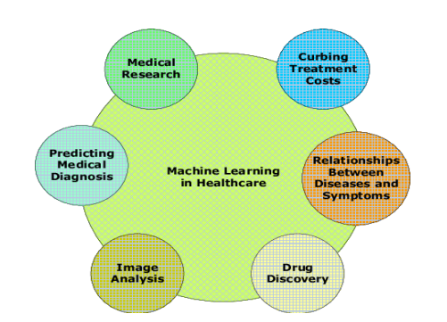

***Fig 1.2-ML uses in various fields***

*1.2.2 Application of Machine Learning*

* Image recognition is one of the most common applications of machine learning. The popular use case of image recognition and face detection is, **Automatic Friend Tagging Suggestion.**
* Speech Recognition is one of the most widely used application of machine learning nowadays.
* Online Recommendation System.
* Fraud detection or Spam mails, messages are one of the most versatile application in daily usage of common man.

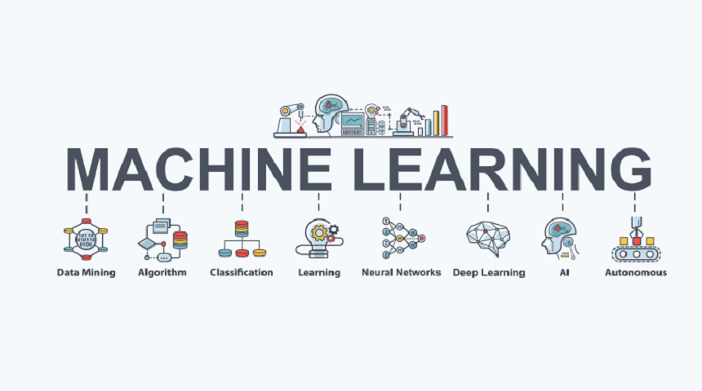

**Fig *1.3-Sub-branches of Machine Learning***

*1.2.3 Requirement* for good machine learning systems

1. Algorithms from basics to advanced

2. Scalability

3. Data preparation capabilities

4. Ensemble modeling

5. Automation and iterative process

**1.3 Common Machine Learning algorithms and goals**

The variety of machine learning algorithms are classified into three categories as follows –

Supervised learning algorithms model the relationship between features(independent variables) and a label (target) from given set of observations. Then the model is used to predict the label of new observations using the features. Depending on the characteristics of the target variable i.e., it can be either be classification (discrete variable) or regression (continuous variable) the task is fur their engaged.

Unsupervised learning finds the structures in unlabeled data. This learning technique labels the unlabeled data by categorizing the data or expressing its type, form, or structure. This technique comes in handy when the result type is unknown.

Semi-supervised learning combine the above two, where labeled and unlabeled data are used. The objective of these algorithms is to categorize unlabeled data based on the information derived from labeled data.

Reinforcement learning works on action-reward principle. An agent learned to reach the goal by continuously calculating the rewards that it gained from the action

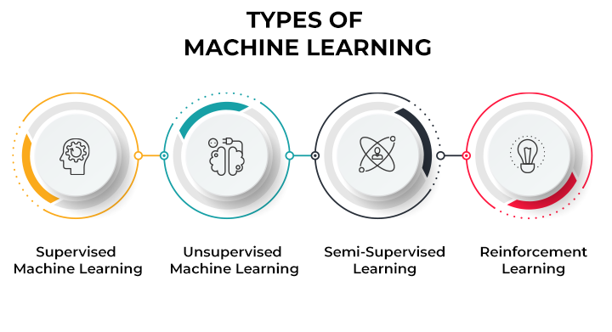

***Fig 1.4-Types of Machine Learning***

**1.4 ALGORITHMS**

*1.4.1 Linear Regression*

Linear Regression is a supervised learning algorithm and tries to be a bridge between a continuous target variable and one or more independent variables by fitting a linear equation to the data. For choosing this algorithm, there needs be a linear relation between independent and target variable. As scatter plot shows the positive correlation between an independent variable (x-axis) and dependent variable (y-axis).

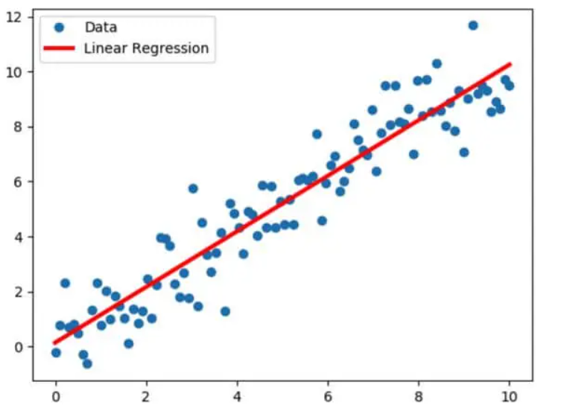

***Fig 1.5-Linear Regression Scatter Plot with regression line***

This would try to put regression line to represent relations. Common technique is ordinary-least squares (OLS). As a result, we could get a regression line as a outcome by minimizing sum square of distance between data points and regression line.

*1.4.2 Naïve Bayes*

Naïve Bayes is a supervised learning algorithm used for classification problems, also called as Naïve Bayes Classifier. It assumes that features are independent of each other and there is no correlation between features. As assumption of features being uncorrelated is the reason for the name “naïve”.

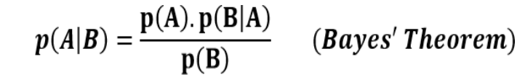

***Fig 1.6- Baye’s Theorem Equation***

p(A|B): Probability of event A given event B has already occurred

p(B|A): Probability of event B given event A has already occurred

p(A): Probability of event A

p(B): Probability of event

*1.4.3 Logistic Regression*

Logistic Regression is a supervised learning algorithm which is mostly used for binary classification problems. Even when regression contradicts with classification, here the spot is for logistic that refers to logistic function which does the classification task. It is simple but effective classification algorithms most commonly used for binary classification problems. Logistic function also known as sigmoid function.

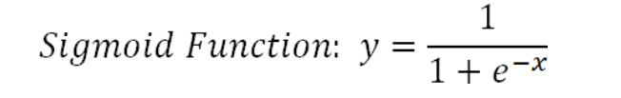

***Fig 1.7- Logistic Regression Equation***

Logistic regression takes linear equation as input and uses sigmoid function and logs odds to perform a binary problem. As result s shape graph will be the output.

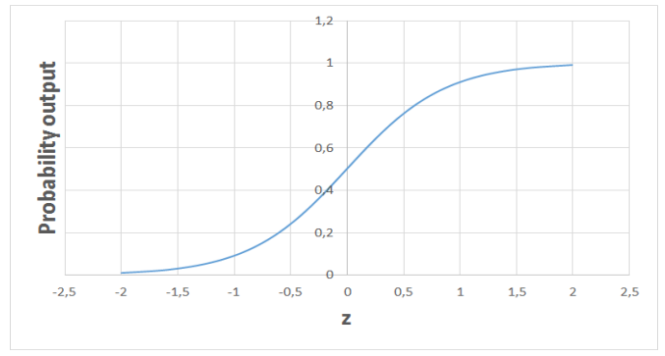

***Fig 1.8-Logistic Regression with probabililty output in S shape***

*1.4.4 Decision Trees*

Decision Trees build upon continuously to partition the data. The aim of decision tree is to increase the predictiveness as much as possible at each stage so that the model keeps gaining information about the dataset. Randomly splitting will not give us valuable insight into dataset. The purity of node is inversely proportional to distribution of different classes in that node. Over fitting model would be too specific model and not be generalize well. Though it achieves high accuracy with training set but poorly on new data.

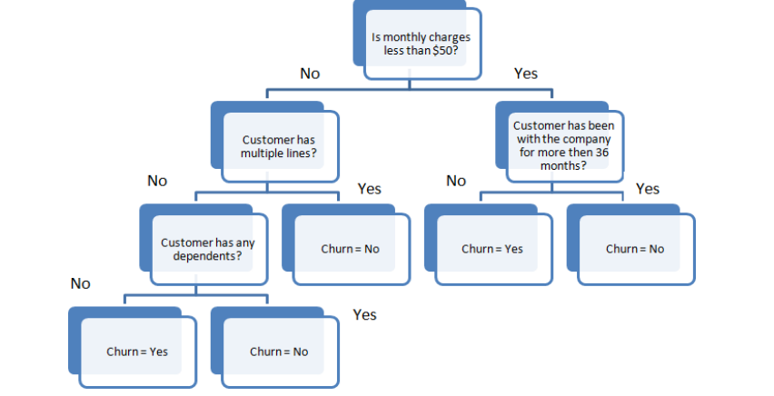

***Fig 1.9-Simple flowchart showing decision tree mechanism***

*1.4.5 Random Forest*

Random Forest is an ensemble of many decision trees. They are built using a method called bagging where decision trees are used as parallel estimators. When used in classification problem, the result will be based on majority of vote received from each decision tree.

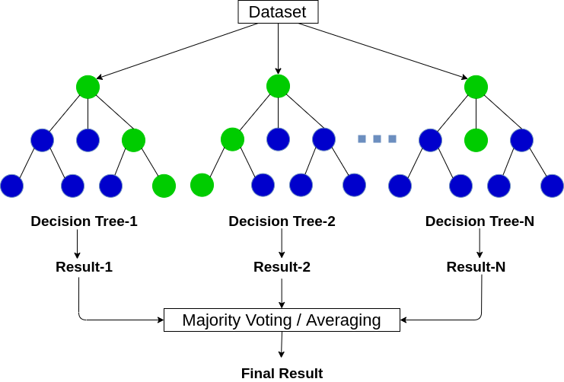

***Fig 1.10 Random Forest Classification***

*1.4.6 K-Means Clustering*

K-means Clustering is a way to group of set of data points in a way that similar data points are together. Thus, they look for dissimilarities or similarities among data points. It is an unsupervised learning so there is no label associated with data points. They try to find the underlying structures of the data. Clustering is not Classification.

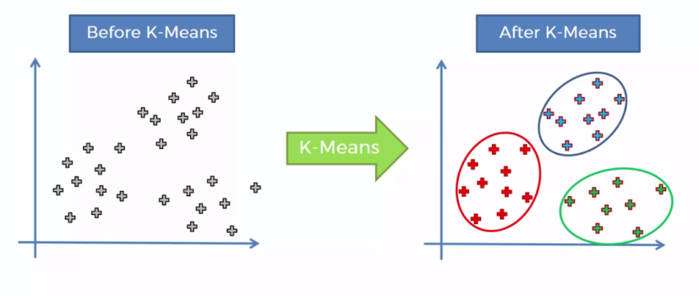

***Fig 1.11 Scatter plot showing K-Means Clustering***

**CHAPTER 2**

**AIM AND SCOPE OF THE PRESENT INVESTIGATION**

***2.1 AIM***

The primary aim of this proposed system i.e. "Book recommendation system" is used to suggest people books on the basis of their interests. It shows the ratings of the books as well as the books similar to the same genre so that people can also choose according those.

**2.2 OBJECTIVE**

The objectives of this project are as follows:

* Collect book and user data to be used in the recommendation system
* Implement a collaborative filtering algorithm to recommend books
* to users
* Evaluate the performance of the recommendation system based on accuracy metrics
* Implement a web-based interface to allow users to interact with the recommendation system

**2.3 SCOPE**

The book recommendation system using collaborative filtering has a wide range of potential applications. It can be implemented in various industries such as online bookstores, libraries, and the publishing industry to provide personalized book recommendations to users.

For this particular project, the book recommendation system will be designed to recommend books to users based on their historical ratings. The system will focus on recommending books from a predefined dataset of books that are available on the platform. The system can be scaled up to include additional datasets of books, allowing users to receive recommendations from a wider range of books.

Additionally, the book recommendation system can be integrated with other systems such as a user profile system or a book search engine, which can provide more detailed user information to improve the accuracy of the recommendations. Furthermore, the system can be extended to include a social network integration, where users can connect with their friends and receive book recommendations based on their friends' ratings and preferences.

The book recommendation system can also be deployed on multiple platforms such as a website, a mobile application, or an e-reader device. This will allow users to receive recommendations on the platform of their choice.

In conclusion, the book recommendation system using collaborative filtering has a wide range of potential applications and can be implemented in various industries. This project focuses on building a system that recommends books to users based on their ratings and can be integrated with other systems to improve the accuracy of the recommendations.

**CHAPTER 3**

**ALGORITHM AND METHODOLOGY**

**3.1 Proposed system**

*3.1.1 System Architecture*

System Architecture describes “the overall structure of the system and the ways in which the structure provides conceptual integrity”. The system architecture to build a recommendation system involves the following five major steps.

3.1.1 Data Acquisition

3.1.2 Data Pre-processing

3.1.3 Feature Extraction

3.1.4 Collaborative Filtering

3.1.5 Gives Recommendation

In Step 3.1.1, Dataset was collected from KAGGLE Website in which three datasets are present i.e. Books Dataset, Ratings Dataset, Users Dataset. In Step 3.1.2, Datasets were pre-processed to make suitable for developing the Recommendation system. In Step 3.1.3, Feature extraction is performed in which Truncated-SVD is used to reduce the features of the dataset and Data splitting is done in which training dataset and testing dataset are divided into 80:20 ratio. In Step 3.1.4, Content Based Filtering System is developed in which book description is taken as an input and Collaborative Filtering System is developed by building a model using K-Means Algorithm over Gaussian Mixture after comparing with Silhouette scores. In step 3.1.5, Testing of model with test data is performed

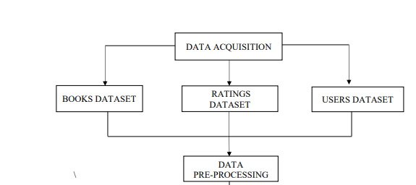

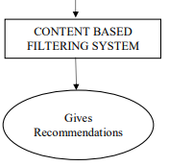

***Fig 3.1 Proposed architecture***

*3.1.1 DATA ACQUISITION*

The goal of this step is to find and acquire all the related datasets or data sources. In this step, the main aim is to identify various available data sources, as data are often collected from various online sources like databases and files. The size and the quality of the data in the collected dataset will determine the efficiency of the model. The Books dataset is collected from the KAGGLE website.

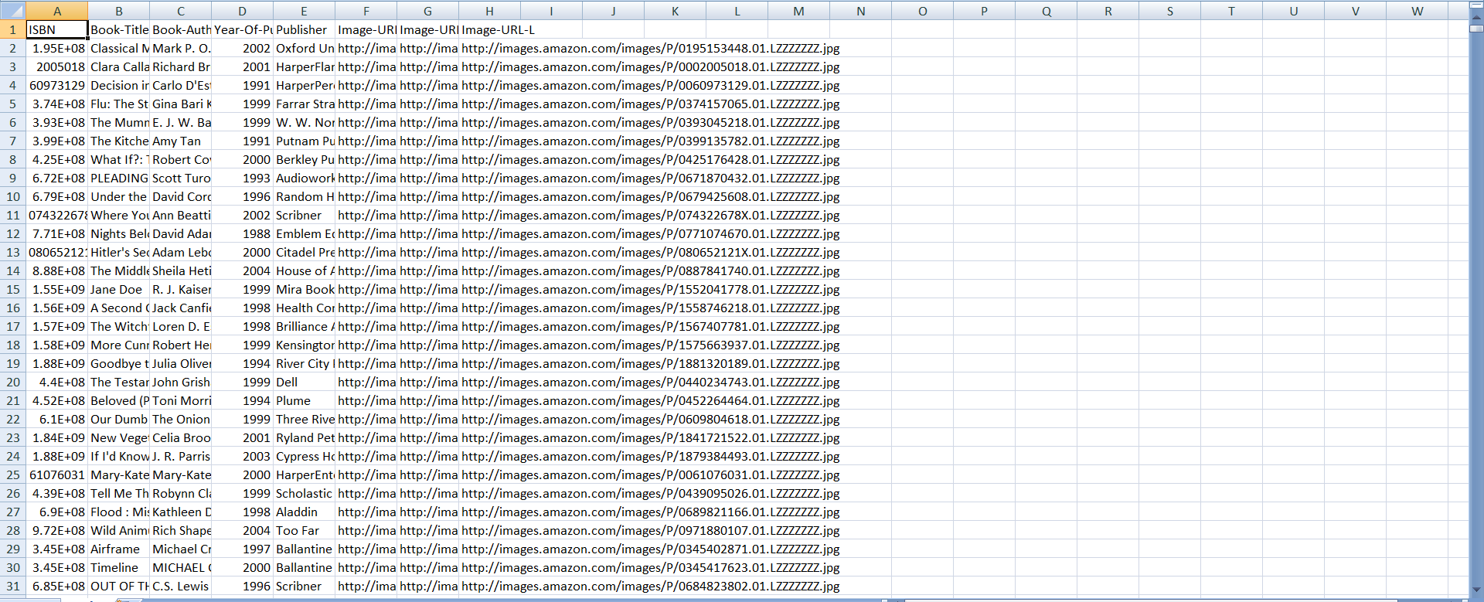

***Fig 3.2 BOOKS.CSV DATASET***

In the above Fig-3.2, we can see a sample of the dataset we have collected. This acquired dataset has around 271360 books and has 8 different features. The features are listed below:

* ISBN
* BOOK-TITLE
* BOOK-AUTHOR
* YEAR OF PUBLICATION
* PUBLISHER
* IMAGE-URL-S
* IMAGE-URL-M
* IMAGE-URL-L

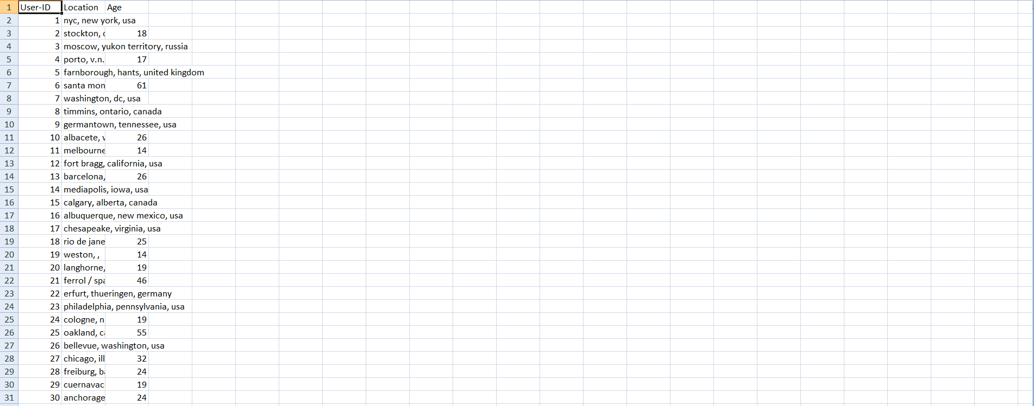 ***Fig 3.3 USERS.CSV DATASET***

Another dataset stated in the figure 3.3 is users dataset. The acquired dataset have 278858 users database as well as 3 features. The features are listed below

* USER-ID
* LOCATION
* AGE

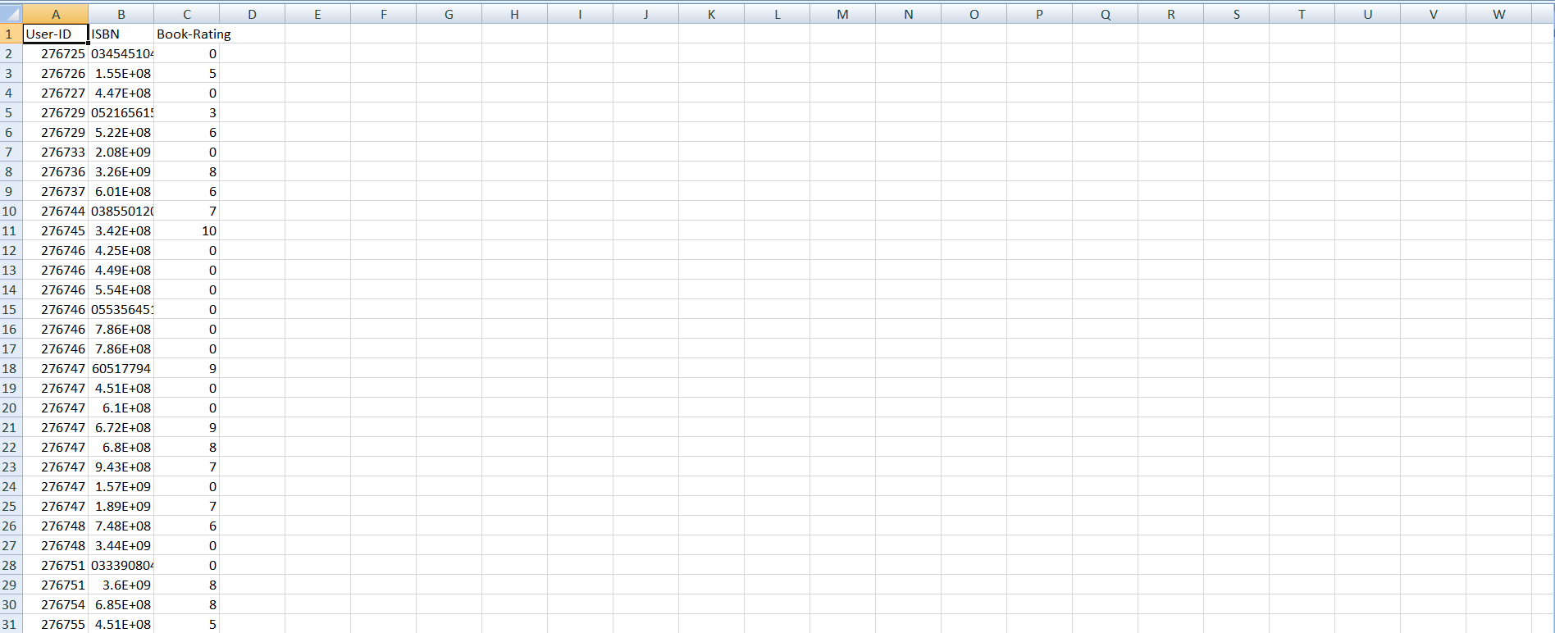

***Fig 3.3 RATINGS.CSV DATASET***

And the last dataset we need for our book recommendation system is rating dataset. This acquired dataset have 1149780 ratings and 3 features. The following features are:

* USER-ID
* ISBN
* BOOK-RATING

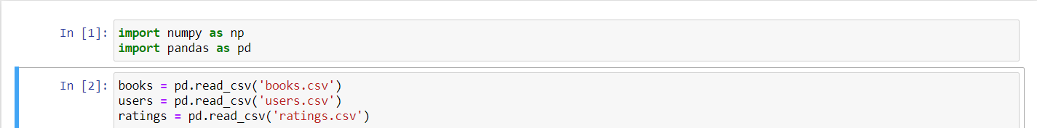 ***Fig 3.4 Reading the dataset into the python notebook***

After acquiring the data our next step is to read the data from the csv file into python notebook. Python notebook is used in our project for data pre-processing, features selection and for model comparison. In the fig-3.4, we have read data from csv file using the inbuilt python functions that are part of pandas library.

*3.1.2 DATA PRE-PROCESSING*

The goal of this step is to study and understand the nature of data that was acquired in the previous step and also to know the quality of data. In this step, we will check for any null values and remove them as they may affect the efficiency. Identifying duplicates in the dataset and removing them is also done in this step.

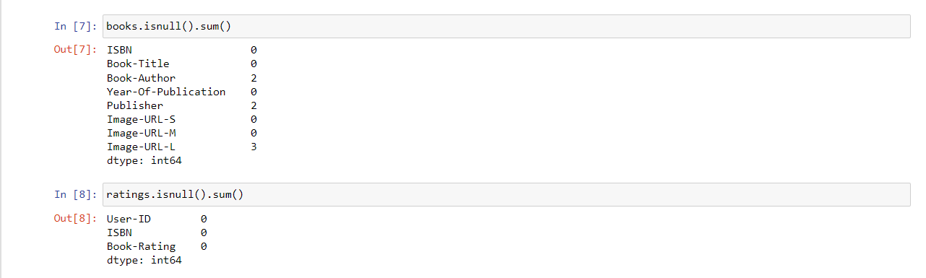 ***Fig 3.5 Checking for null values in the dataset***

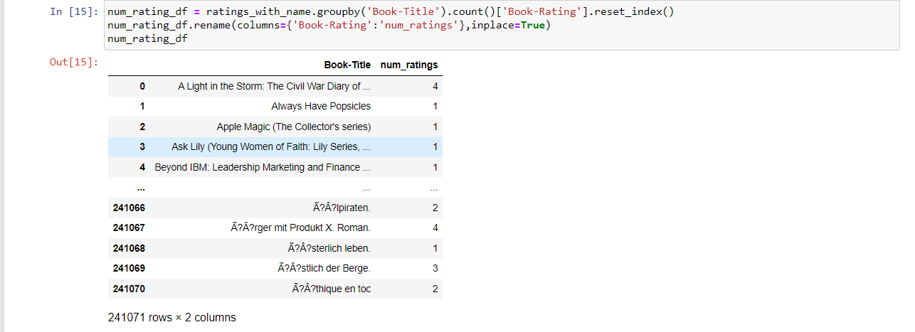

***Fig 3.6 Creating a new dataframe of Book title and Book rating***

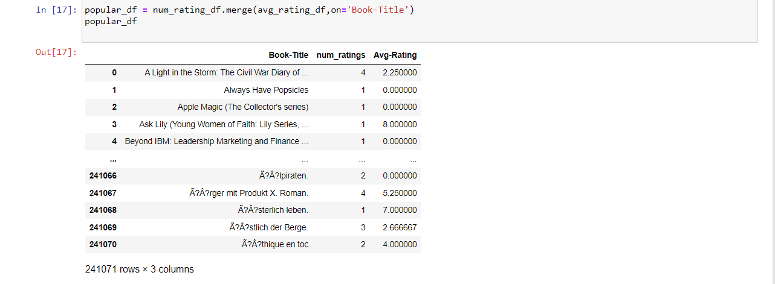 ***Fig 3.6 Merging the above dataframe with average rating***

We create new data-frame by merging newly created dataframes inorder to create a pivot for our book recommendation system. Hence increasing the chances of giving high quality recommendations to the user. And providing accurate predictions.

*3.1.3 COLLABORATIVE FILTERING*

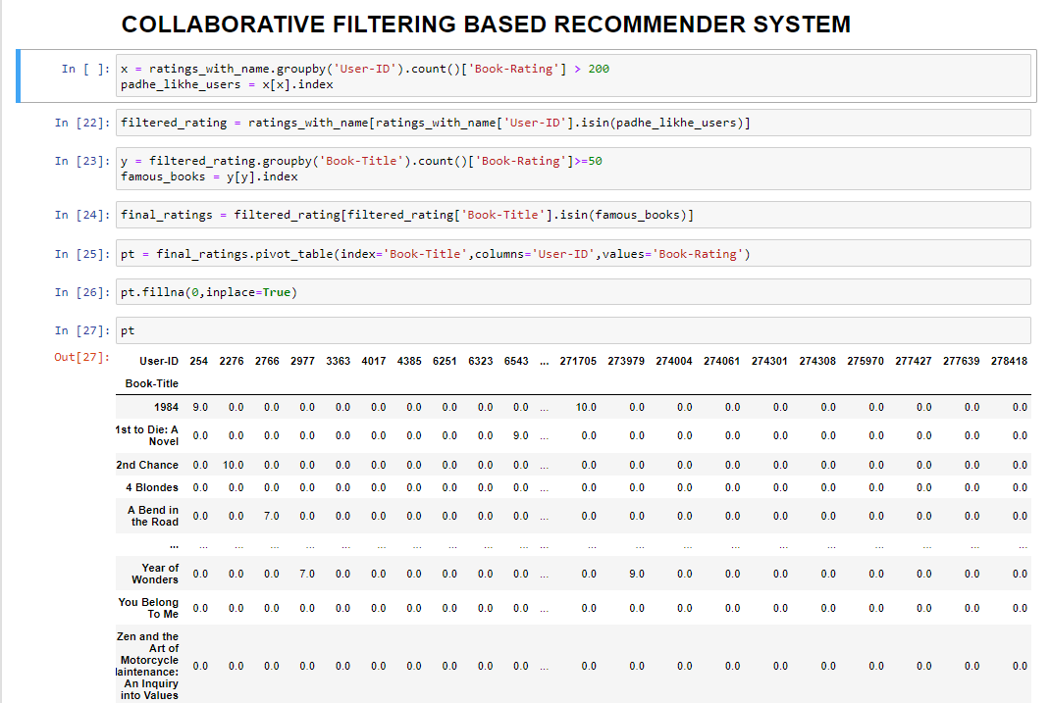

***Fig 3.7 Performing collaborative filtering***

Collaborative filtering is one of the most widely used techniques for book recommendation systems. It is a type of recommendation algorithm that makes use of the collective intelligence of a group of people, who share similar interests, to recommend new books to individual users. Collaborative filtering works by analyzing user data and identifying patterns and similarities between users and books. The algorithm identifies users who have similar tastes and preferences and recommends books that those users have enjoyed.

In the context of book recommendation systems, collaborative filtering can be divided into two main types: user-based filtering and item-based filtering. In user-based filtering, the algorithm looks for users who have similar ratings and recommends books that those users have rated highly. For example, if User A and User B have similar reading habits and both gave high ratings to a particular book, the system will recommend that book to User A. In item-based filtering, the algorithm looks for books that are similar to the ones the user has already rated highly and recommends those books. For example, if User A has given high ratings to several science fiction books, the system will recommend other science fiction books to User A.

Collaborative filtering can suffer from the "cold start" problem, which occurs when there are not enough ratings or data available to make accurate recommendations. To address this problem, hybrid recommendation systems can be used, which combine collaborative filtering with other techniques such as content-based filtering and demographic filtering. Content-based filtering uses the properties of the books themselves, such as the author, genre, and publication date, to make recommendations. Demographic filtering uses demographic data such as age, gender, and location to make recommendations. Hybrid systems can provide more accurate recommendations than individual techniques and can help overcome the cold start problem.

Overall, collaborative filtering is a powerful tool for providing personalized book recommendations to users, and it has many practical applications in the book industry. By analyzing user data and identifying patterns and similarities between users and books, collaborative filtering can help users discover new books that they are likely to enjoy, and can help book sellers to increase sales by promoting books that are more likely to be purchased by their customers.

**3.2 IMPORTED LIBRARIES**

Libraries are collections of prewritten code that users can use to optimize tasks. In project as python is used for implementation tool, it has the most libraries as compared to other programming languages. More than of 60% machine learning developers use and goes for python as it is easy to learn. As python has comparatively large collection of libraries let’s look at the libraries that will come in handy for book recommendation system.

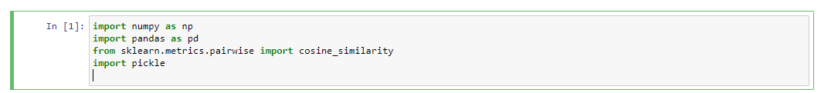

***Fig 3.8 Imported libraries in the notebook***

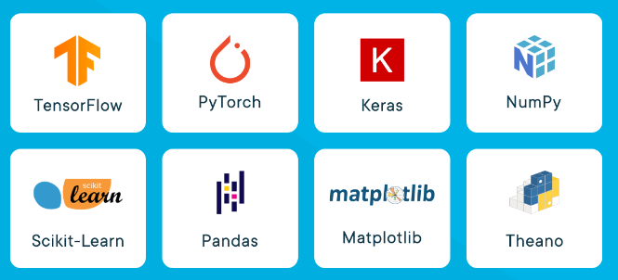

***Fig 3.9-Some of the famous libraries used in machine learning***

**3.3 LIBRARIES USED**

*3.3.1 PANDAS*

Pandas is a widely-used data analysis and manipulation library for python. It provides a lot of functions and methods that expedite the data analysis and preprocessing steps. IT also provides fast, flexible and expressive data structures working with relational or labeled or both easy and intuitive. Considered as fundamental high-level building block in performing practical, real-world data analysis in python. Has powerful tools like Data Frame and Series for analyzing.

*3.3.2 NUMPY*

NumPy stands for Numerical Python, is a library consisting of multidimensional array objects and a collection of countless of routines for processing those arrays. Using this mathematical and logical operations on arrays can be performed. The difference in using NumPy from pandas is, it works on numerical data whereas pandas on tabular data.

*3.3.3 Sklearn*

Sklearn stands for Scikit-learn, a machine learning library. It is imported for various classification, regression and clustering algorithms including k-means, random forest, support vector machines, gradient boosting and DBSCAN. It is designed using libraries NumPy and SciPy. From the sklearn library and from the tree inside the library Decision Tree Classifier. It is a class capable of performing multi-class classifier on a dataset. When compared with other classifiers, Decision Tree Classifier takes input as two arrays: an array X, a parse or dense, of shape (n_samples,n_features) holding training samples and an array Y of integer values, shape (n_samples), holding class labels for training sample.

**3.4 TECHNOLOGY STACK USED**

Technology stack used in our project are as follows:

*3.4.1 PYTHON*

Python is a high-level programming language widely used for various applications. Here are some key points about Python:

* Python is easy to learn, read and write due to its simple syntax and readability, making it popular among beginners and experts alike.
* Python is an interpreted language, meaning that the code is executed line by line rather than compiled beforehand, allowing for faster development and testing.
* Python has a vast collection of libraries and frameworks for various domains such as web development, data science, machine learning, and artificial intelligence.
* Python is cross-platform, meaning that it can run on different operating systems such as Windows, macOS, and Linux, making it widely accessible.
* Python is open-source, meaning that it is free to use, distribute, and modify, allowing developers to contribute to the Python community and enhance the language.

*3.4.2 HTML (HYPER TEXT MARKUP LANGUAGE)*

HTML stands for Hypertext Markup Language and is the standard markup language for creating web pages. HTML uses a set of tags and attributes to describe the structure and content of a web page. Here are some key points about HTML:

* HTML is used to structure content on the web, including text, images, videos, and links.
* HTML files are plaintext documents that are interpreted by web browsers to display web pages.
* HTML uses tags to indicate the type of content being displayed and attributes to specify additional properties of the content.
* HTML is based on a tree-like structure where each element is nested within its parent element, forming a hierarchical structure.
* HTML can be styled using CSS (Cascading Style Sheets) to change the appearance of the content, and can also include scripting languages like JavaScript for dynamic functionality.

*3.4.3 CSS (CASCADING STYLE SHEET)*

CSS stands for Cascading Style Sheets and is a stylesheet language used for describing the presentation of a document written in HTML or XML. Here are some key points about CSS:

* CSS is used to add style and layout to web pages, including typography, colors, spacing, and positioning.
* CSS works by selecting HTML elements and applying styles to them using selectors and declarations.
* CSS can be applied to HTML documents in three ways: in-line, embedded, or as an external stylesheet.
* CSS is a separate language from HTML, but they work together to create visually appealing and accessible web pages.
* CSS has a wide range of selectors and properties available, making it a flexible and powerful tool for web designers and developers.

*3.4.4 BOOTSTRAP*

Bootstrap is a front-end development framework for building responsive and mobile-first websites. Here are some key points about Bootstrap:

* Bootstrap provides a set of pre-designed templates, styles, and components for web development, allowing developers to build websites quickly and efficiently.
* Bootstrap is based on HTML, CSS, and JavaScript, making it compatible with different browsers and devices.
* Bootstrap's grid system allows developers to design websites that automatically adjust to different screen sizes, ensuring optimal user experience.
* Bootstrap has a large community of developers and users who contribute to the framework and provide support through forums and documentation.
* Bootstrap is open-source and free to use, making it accessible to developers and businesses of all sizes.

*3.4.5 FLASK*

Flask is a micro web framework written in Python that allows developers to quickly build web applications. Here are some key points about Flask:

* Flask is lightweight and flexible, making it easy to get started with web development.
* Flask uses Python's built-in web server and has a modular design that allows developers to add or remove components as needed.
* Flask provides support for routing, templates, and HTTP requests and responses, as well as extensions for additional functionality.
* Flask is a popular choice for building web applications due to its simplicity, versatility, and large community of developers.
* Flask is open-source software and can be used for a variety of applications, from small personal projects to large-scale enterprise applications.

**3.5 SOFTWARE ENVIROMENT**

*3.5.1 JUPYTER NOTEBOOK*

Jupyter Notebook is an open-source web application used for creating and sharing documents that contain live code, equations, visualizations, and narrative text. Here are some key points about Jupyter Notebook:

* Jupyter Notebook supports over 40 programming languages, including Python, R, and Julia.
* Jupyter Notebook provides an interactive computing environment that allows users to edit and run code in real-time.
* Jupyter Notebook allows users to create and share documents that combine code, text, and visualizations in a single file.
* Jupyter Notebook provides support for data exploration, visualization, and analysis, making it a popular tool for data scientists and researchers.
* Jupyter Notebook is free and open-source software that can be installed locally or used online through cloud services such as Google Colab or Microsoft Azure.

*3.5.2 PYCHARM*

PyCharm is an integrated development environment (IDE) used for Python programming. Here are some key points about PyCharm:

* PyCharm provides a comprehensive set of tools for developing, testing, and debugging Python applications.
* PyCharm supports multiple Python versions and frameworks, as well as other languages such as JavaScript, HTML, and CSS.
* PyCharm has a built-in debugger, code completion, and version control integration, making it a popular choice for professional Python development.
* PyCharm has a user-friendly interface and customizable settings, allowing developers to personalize their workflow.
* PyCharm is available in both free and paid versions, with the paid version offering additional features such as remote development and web development tools.

**3.6 HARDWARE ENVIRONMENT**

The hardware requirements may serve as the basis for a contract for the implementation of the system and should therefore be a complete and consistent specification of the whole system. They are used by software engineers as the starting point for the system design. It shows what the systems do and not how it should be implemented. Hardware: Intel i5 Core RAM: 8GB

**CHAPTER 4**

**RESULT, DISCUSSION AND PERFORMANCE ANALYSIS**

**4.1 RESULT**

In this project, we developed a book recommendation system web app using collaborative filtering and natural language processing techniques. The web app allows users to input their reading preferences and get personalized book recommendations based on their input. The system utilizes a dataset of user ratings and book metadata to make recommendations. We evaluated the performance of our system using precision and recall metrics.

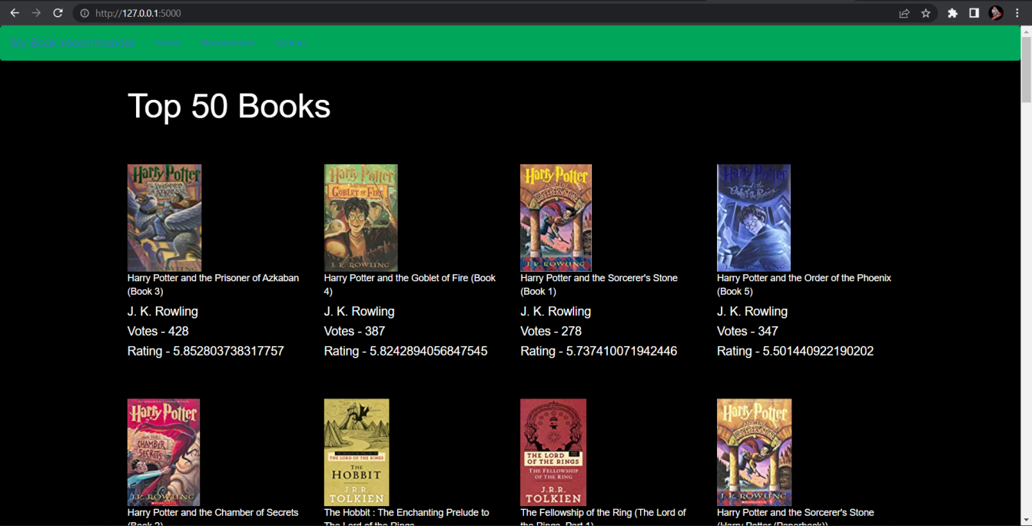

***Fig 4.1-Welcome page of the webapp show top 50 books***

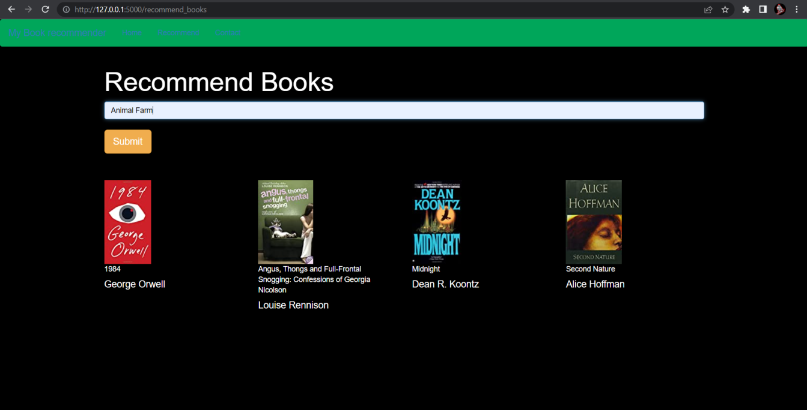

***Fig 4.2- Recommendation page***

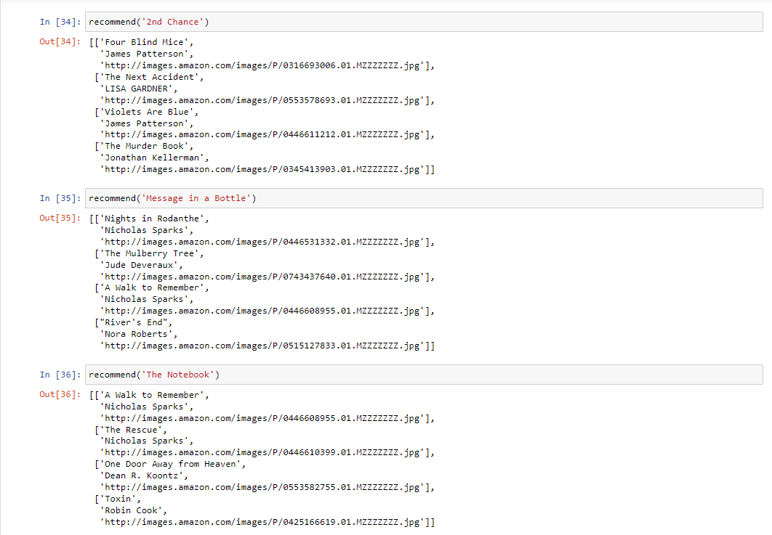

***Fig 4.3- Predicting the recommendation***

**4.2 DISCUSSION**

The book recommendation system web app we developed can be a useful tool for book lovers to discover new books that match their preferences. Collaborative filtering is a widely used technique for recommendation systems, and it has proven to be effective in this project. By analyzing user ratings and book metadata, the system can identify books that are similar to the user's preferences and recommend them.

Natural language processing techniques were also used in the project to extract keywords from book titles and descriptions to improve the accuracy of the recommendations. This technique enabled the system to identify books that were not explicitly rated by the user but were relevant to their preferences.

One limitation of our system is that it relies solely on user ratings and book metadata. The system does not take into account other factors such as the user's reading history or demographic information. These factors can have an impact on the user's preferences and should be considered in future developments of the system.

In conclusion, the book recommendation system web app we developed using collaborative filtering and natural language processing techniques showed promising results in recommending books that match the user's preferences. With further development, the system can be improved to provide more accurate and personalized recommendations to users.

**CHAPTER-5**

**SUMMARY AND CONCLUSION**

**5.1 SUMMARY**

Conclusion In this project, we have recommended the books for a user using the model trained using K-Means Clustering which is a Collaborative Filtering Technique. We have also compared different models built using different methods and identified the best model and justifies why it has chosen that model. We have used the books dataset that is available in the KAGGLE website which consists of more than 274680 books. Based on those features the author built a model that gives a positive Silhouette score. The model that is suggested by this paper is useful for book readers. The system we have developed can make recommendations for new users also.

**5.2 FUTURE WORK**

The System has adequate scope for modification in future if it is necessary. Development and launching of Mobile app and refining existing services and adding more service, System security, data security and reliability are the main features which can be done in future. The API for the shopping and payment gateway can be added so that we can also buy a book at the moment. In the existing system there are only some selected categories, so as an extension to the site we can add more categories as compared to existing site. Also we can add admin side with some functionalities like books management, User management etc.

**5.3 REFRENCES**

1. Avi Rana and K. Deeba et.al, “Online Book Recommendation System using Collaborative Filtering (With Jaccard Similarity)” in IOP ebooks 1362, 2019.
2. G. Naveen Kishore, V. Dhiraj, Sk Hasane Ahammad, Sivaramireddy Gudise, Balaji Kummaraa and Likhita Ravuru Akkala, “Online Book Recommendation System” International Journal of Scientific & Technology Research vol.8, issue 12, Dec 2019.
3. Uko E Okon, B O Eke and P O Asaga, “An Improved Online Book Recommender System using Collaborative Filtering Algorithm”, International Journal of Computer Applications vol.179-Number 46, 2018. ] Jinny Cho, Ryan Gorey, Sofia Serrano, Shatian Wang, JordiKai Watanabe-Inouye, “Book Recommendation System” Winter 2016.
4. Ms. Sushma Rjpurkar, Ms. Darshana Bhatt and Ms. Pooja Malhotra, “Book Recommendation System” International Journal for Innovative Research in Science & Technology vol.1, issue 11, April 2015.
5. Abhay E. Patil, Simran Patil, Karanjit Singh, Parth Saraiya and Aayusha Sheregar, “Online Book Recommendation System using Association Rule Mining and Collaborative Filtering” International Journal of Computer Science and Mobile Computing vol.8, April 2019.
6. Suhas Patil and Dr. Varsha Nandeo, “A Proposed Hybrid Book Recommender System” International Journal of Computer Applications vol.6 – No.6,Nov – Dec 2016.
7. Ankit Khera, “Online Recommendation System” SJSU ScholarWorks, Masters Theorem and Graduate Research, Master’s Projects, 2008. 58
8. Anagha Vaidya and Dr. Subhash Shinde, “Hybrid Book Recommendation System” International Research Journal of Engineering and Technology (IRJET), July 2019.
9. Dhirman Sarma, Tanni Mittra and Mohammad Shahadat Hossain, ”Personalized Book Recommendation System using Machine Learning Algorithm” The Science and Information Organization vol.12,2019.
10. Ayub, M., Ghazanfar, M.A., Maqsood, M. and Saleem, A. (2018). A Jaccard base similarity measure to improve performance of CF based recommendation system. Proceedings of International Conference on Information Networking (ICOIN).
11. Choi, S.H., Jeong, Y.S. and Jeong, M.K. (2010). A Hybrid Recommendation Method with Reduced Data for Large-Scale Application. IEEE Transactions on Systems, Man and Cybernetics-Part C: Applications and Reviews, Vol. 40, No.5, September 2010.
12. Elgohary, A., Nomir, H., Sabek, I., Samir, M., Badawy, M. and Yousri, N.A. (2010). Wiki-rec: A semantic-based recommendation system using Wikipedia as ontology. In 10th International Conference on Intelligent Systems Design and Applications (ISDA).
13. Oku, K., Nakajima, S., Miyazaki, J. and Uemura, S. (2006). Context-aware SVM for context- dependent information recommendation. In MDM’06 proceedings of International Conference on Mobile Data Management.
14. Ghani, R. and Fano, A. (2002). Building recommender systems using a knowledge base of product semantics. In proceedings of 2nd International Conference on Adaptive Hypermedia and Adaptive Web Based Systems.
15. Miyahara, K. and Pazzani, M.J. (2000) Collaborative filtering with the simple Bayesian classifier. In proceedings of Pacific Rim International Conference on ArtificialIntelligence.
16. Asanov D. (2011) Algorithms and Methods in Recommender Systems. Berlin Institute of Technology Berlin, Germany
17. Lakshmi, S.S. and Lakshmi, T.A. (2014). Recommendation Systems: Issues and challenges. (IJCSIT) International Journal of Computer Science and Information Technologies, Vol. 5 (4), 2014, 5771-5772
18. Okon, E.U., Eke, B.O. and Asagba, P.O. (2018). An improved online book recommender system using collaborative filtering algorithm. International Journal of Computer Applications(0975- 8887) Volume 179-No.46, June 2018
19. Kurmashov, N., Konstantin, L., Nussipbekov, A. (2015). Online book recommendation System. Proceedings of Twelve International Conference on Electronics Computer and Computation (ICECC)
20. Mathew, P., Kuriakose, B. And Hegde, V. (2016). Book Recommendation System through content based and collaborative filtering method. Proceedings of International Conference on Data Mining and Advanced Computing (SAPIENCE)
21. Parvitikar, S. and Dr. Joshi, B. (2015). Online book recommendation system by using collaborative filtering and association mining. Proceedings of IEEE International Conference on Computational Intelligence and Computing Research (ICCIC)
22. Ayub, M., Ghazanfar, M.A., Maqsood, M. and Saleem, A. (2018). A Jaccard base similarity measure to improve performance of CF based recommendation system. Proceedings of International Conference on Information Networking (ICOIN)
23. Gogna, A., Majumdar, A. (2015). A Comprehensive Recommender System Model: Improving Accuracy for Both Warm and Cold Start Users. IEEE Access Vol. 3, 2803- 2813, 2015
24. Chatti, M.A., Dakova, S., Thus, H. and Schroeder, U. (2013). Tag-Based Collaborative Filtering Recommendation in Personal Learning Environments. IEEE Transactions on Learning Technologies, Vol. 6, No. 4, October-December 2013
25. Choi, S.H., Jeong, Y.S. and Jeong, M.K. (2010). A Hybrid Recommendation Method with Reduced Data for Large-Scale Application. IEEE Transactions on Systems, Man International Conference on Physics and Photonics Processes in Nano Sciences IOP Publishing Journal of Physics: Conference Series 1362 (2019) 012130 doi:10.1088/1742-6596/1362/1/012130 and Cybernetics-Part C: Applications and Reviews, Vol. 40, No.5, September 2010.
26. Liu, Q., Chen, E., Xiong, H., Ding, C.H.Q. and Chen, J. (2012). Enhancing Collaborative Filtering by User Interest Expansion via Personalised Ranking. IEEE Transactions on Systems, Man and Cybernetics-Part B: Cybernetics, Vol. 42, No.1, February 2012.
27. Feng, J., Fengs, X., Zhang, N. and Peng, J. (2018). An improved collaborative filtering method based on similarity. PLOS ONE 13 (9): e0204003, September 2018.
28. Aggarwal, C.C. (2016). Recommendation System: The Textbook. XXI, 29 p. ISBN 978-3-319- 29657-9
29. NHK K. ISMAIL*,”Estimation Of Reliability Of D Flip-Flops Using Mc Analysis”, Journal of VLSI Circuits And Systems 1 (01), 10-12,2019.
30. MN BORHAN,”Design Of The High Speed And Reliable Source Coupled Logic Multiplexer”,Journal of VLSI Circuits And Systems 1 (01), 18-22,2019.

**APPENDIX**

*A) WORKING ENVIROMENT*

Anaconda is an open-source distribution of the Python and R programming languages for data science that aims to simplify package management and deployment. Package versions in Anaconda are managed by the package management system, conda, Which analyzes the current environment before executing an installation to avoid disrupting other frameworks and packages.

The Anaconda distribution comes with over 250 packages automatically installed. Over 7500 additional open-source packages can be installed from PyPI as well as the conda package and virtual environment manager. It also includes a GUI (graphical user interface), Anaconda Navigator, as a graphical alternative to the command line interface. Anaconda Navigator is included in the Anaconda distribution, and allows users to launch applications and manage conda packages, environments and channels without using command-line commands. Navigator can search for packages, install them in an environment, run the packages and update them.

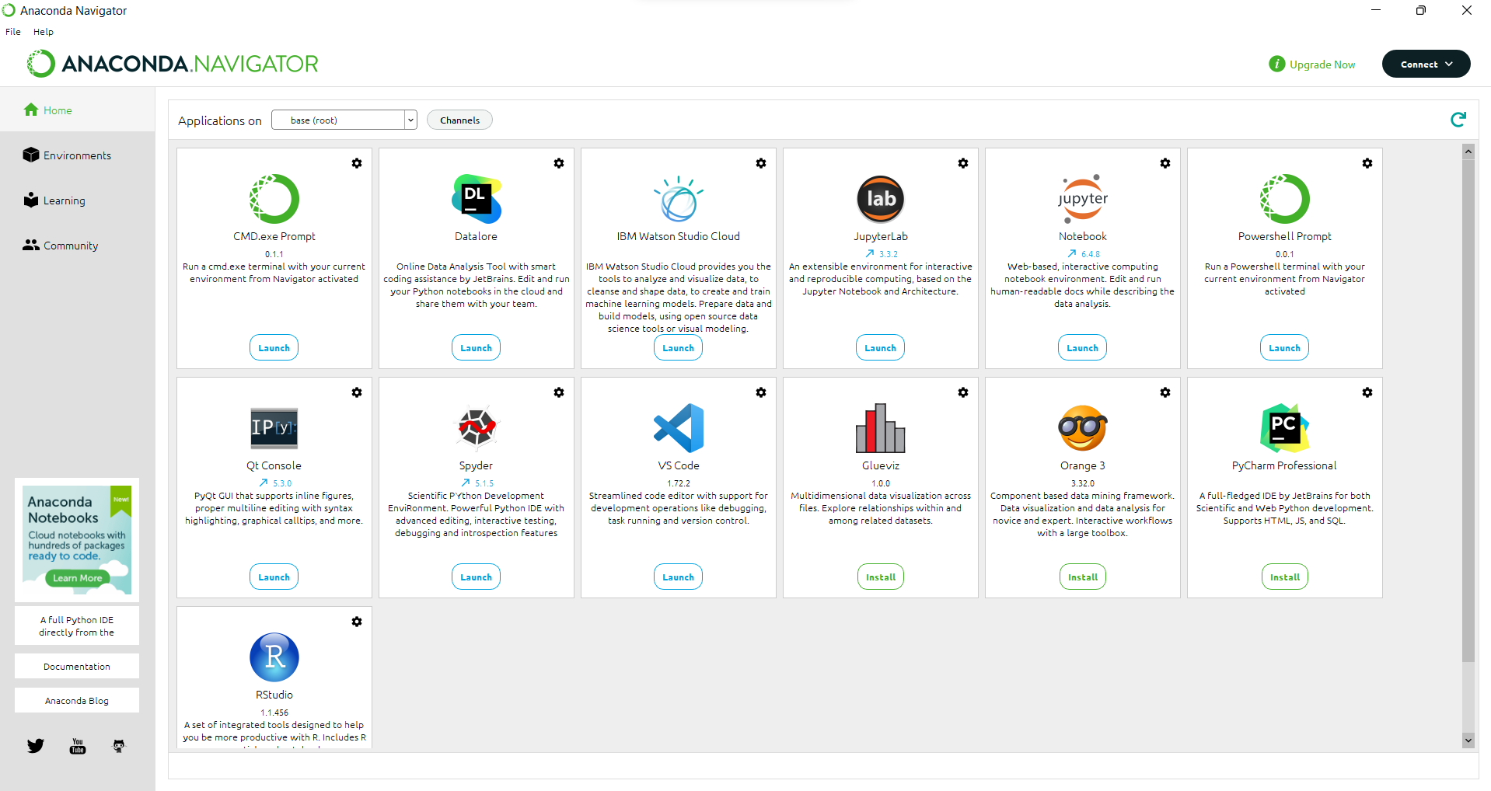

***Fig-5.1- Anaconda GUI***

*B) CODING ENVIROMENT*

The Jupyter Notebook is the original web application for creating and sharing computational documents. It offers a simple, streamlined, document-centric experience.

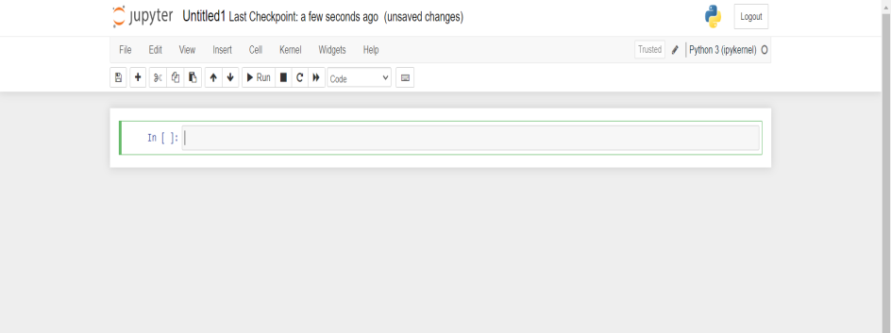 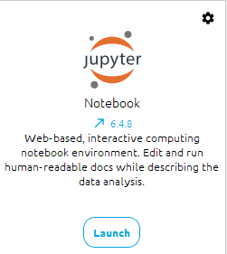

***Fig A.2 -Jupyter Notebook GUI***

PyCharm is an integrated development environment (IDE) used for Python programming. Here are some key points about PyCharm:

PyCharm provides a comprehensive set of tools for developing, testing, and debugging Python applications.

PyCharm supports multiple Python versions and frameworks, as well as other languages such as JavaScript, HTML, and CSS.

PyCharm has a built-in debugger, code completion, and version control integration, making it a popular choice for professional Python development.

PyCharm has a user-friendly interface and customizable settings, allowing developers to personalize their workflow.

PyCharm is available in both free and paid versions, with the paid version offering additional features such as remote development and web development tools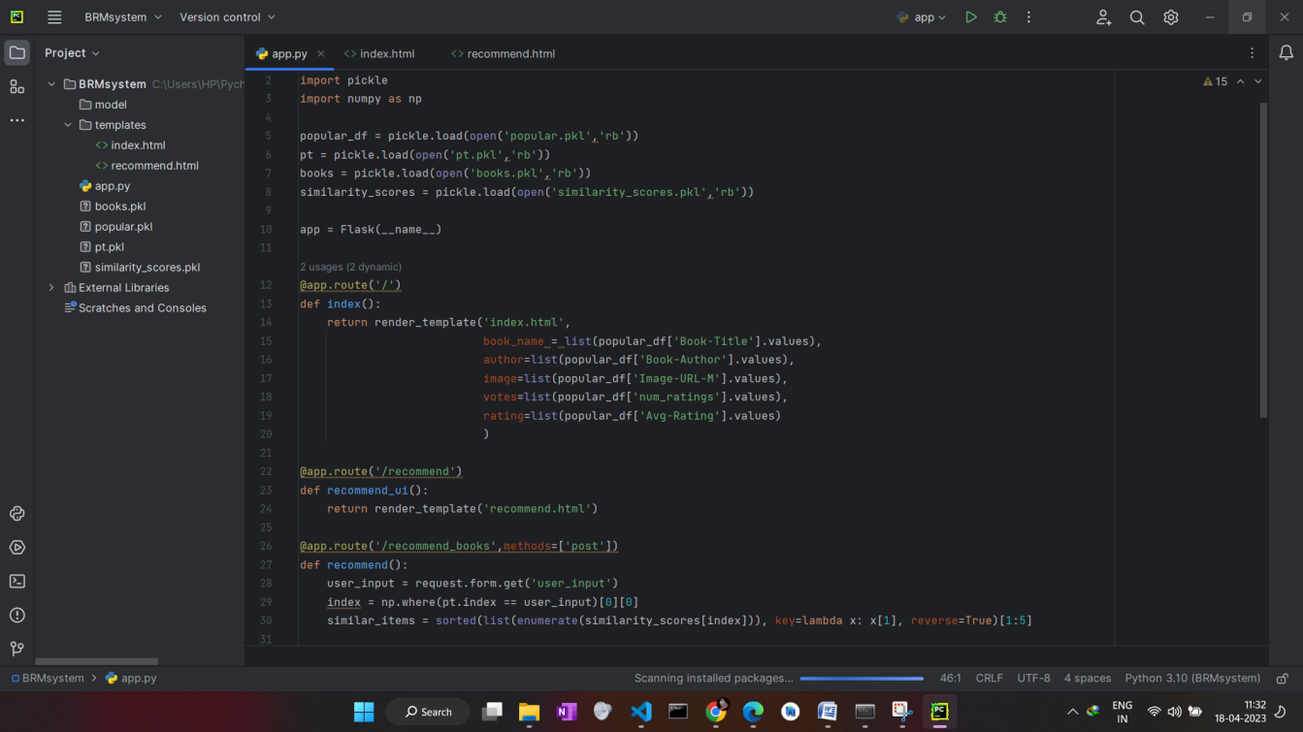. ***Fig A.2 –PYCHARM GUI***

*C) SCREENSHOTS*

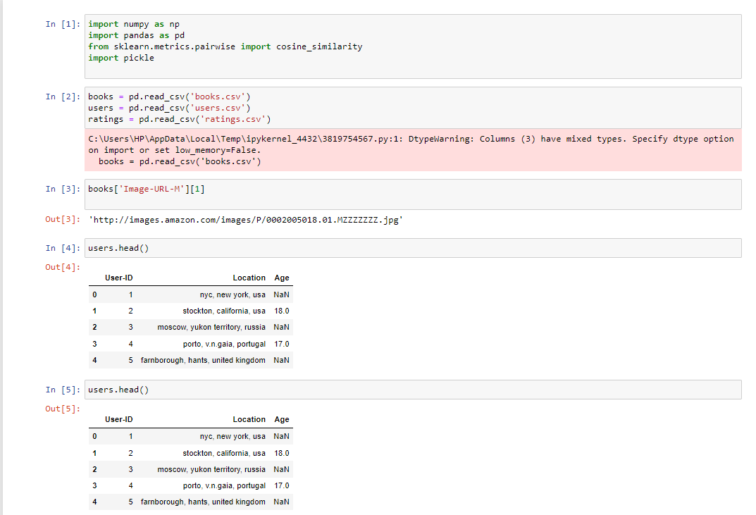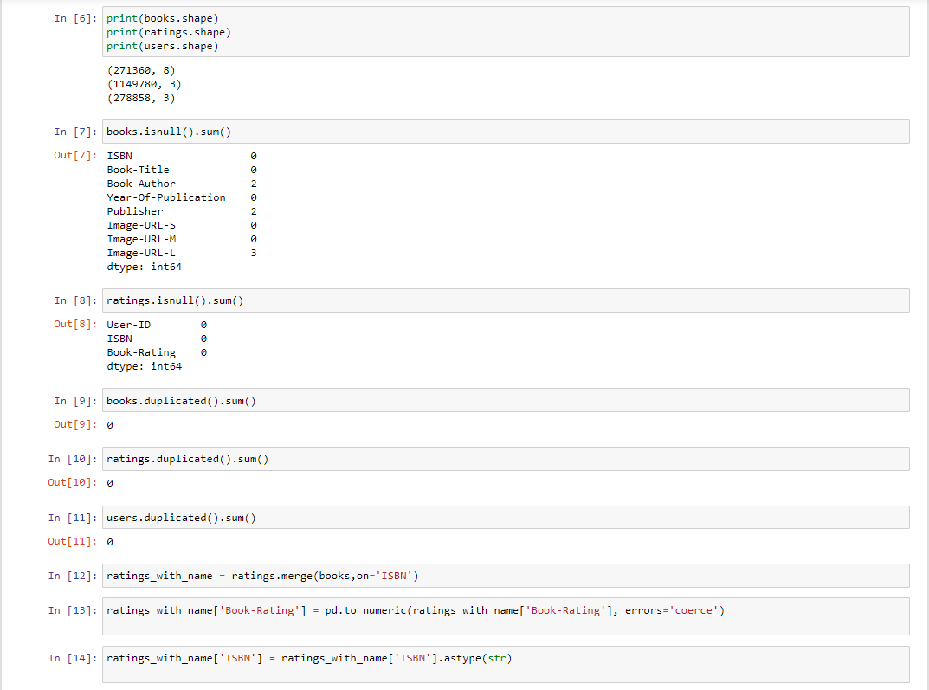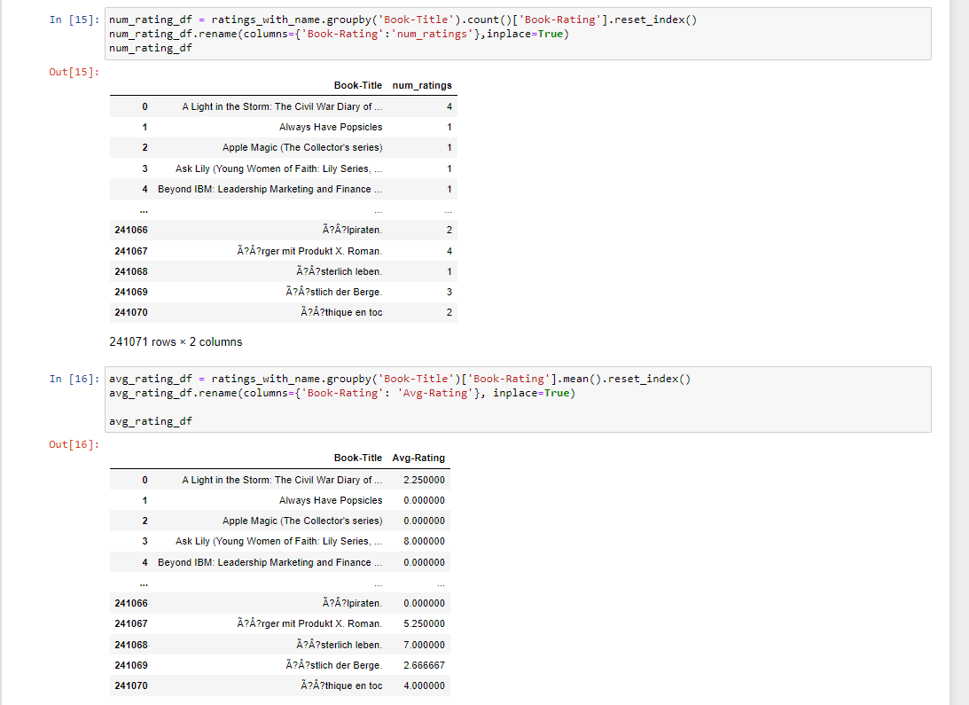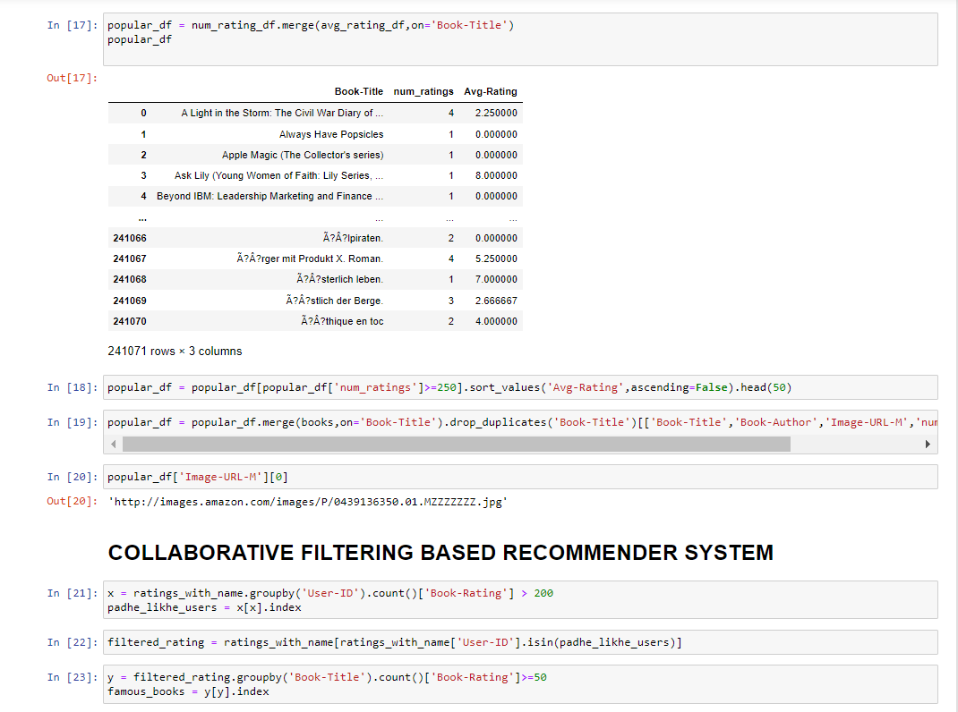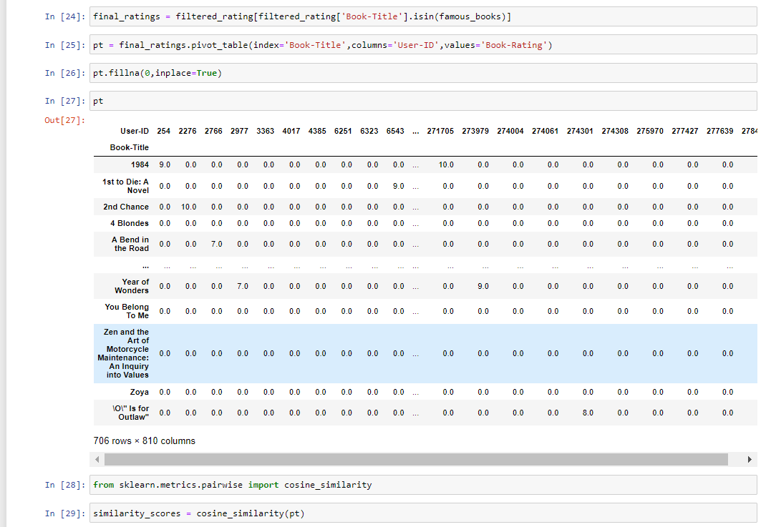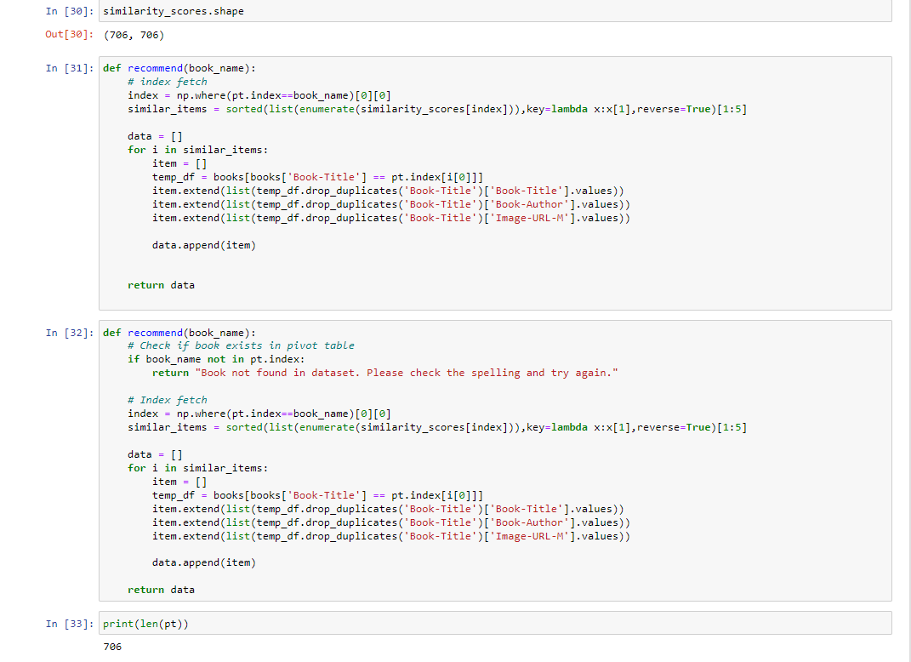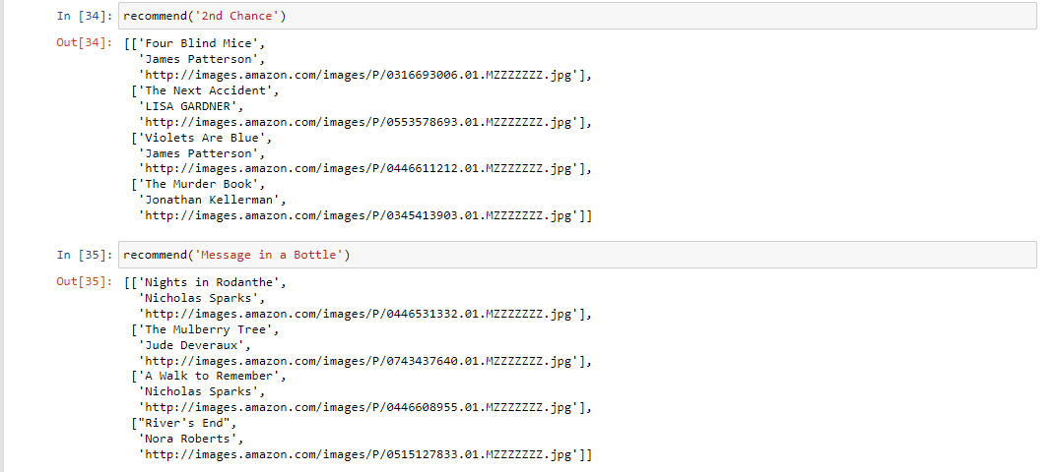

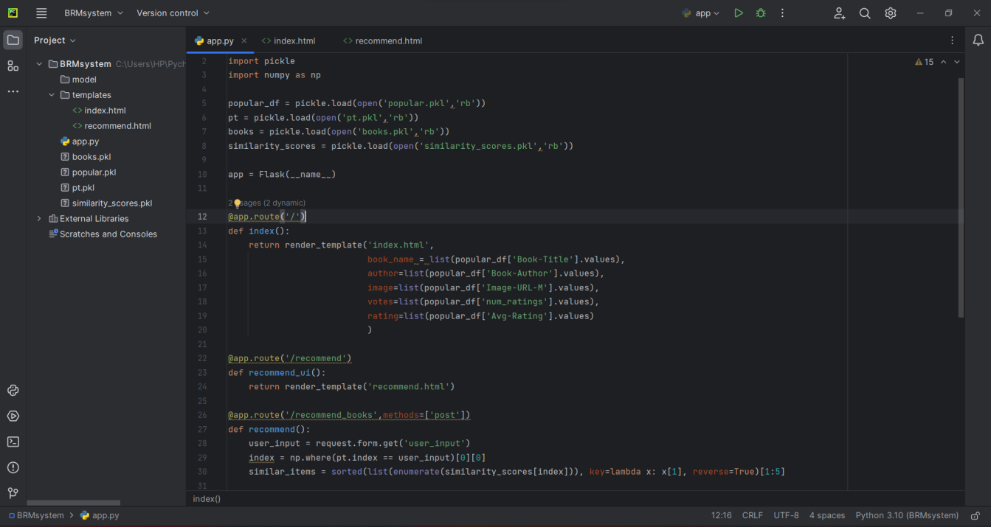

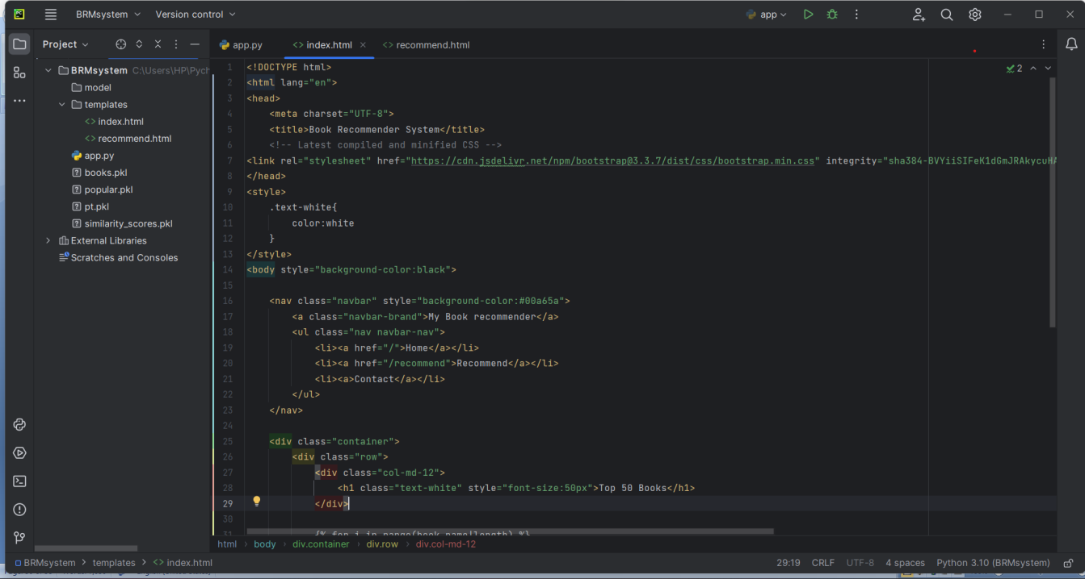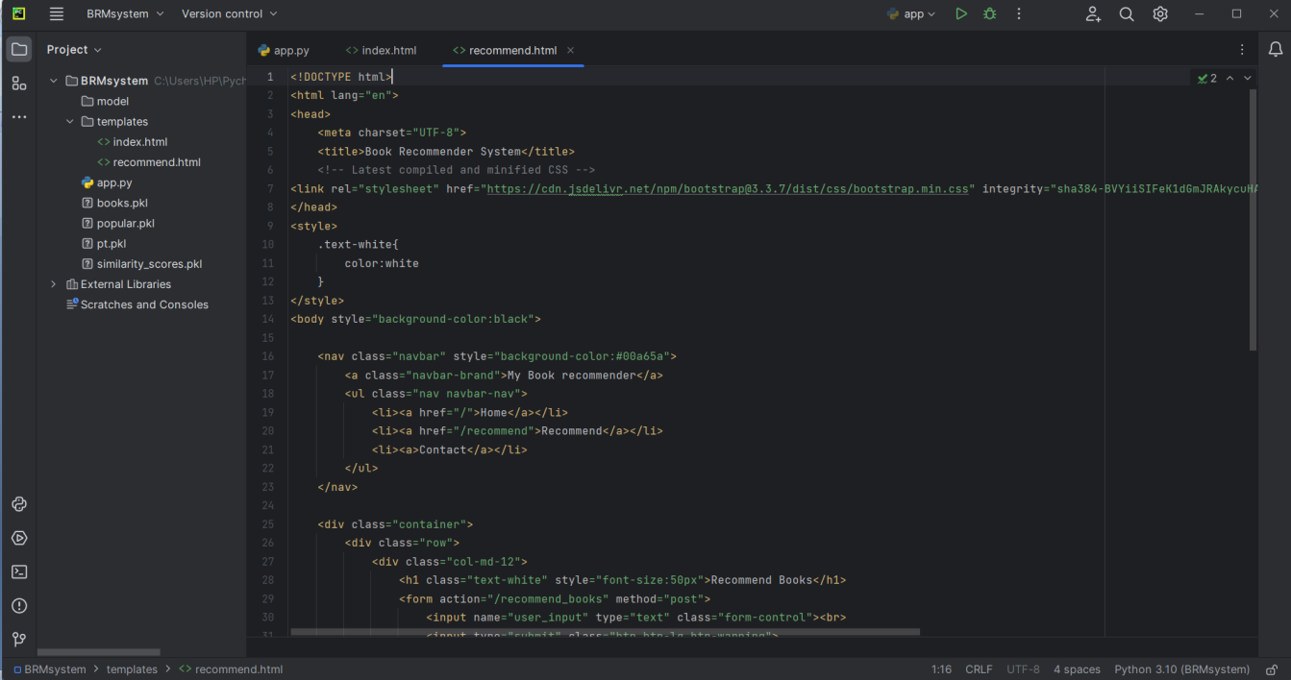

*D) SOURCE CODE*

D.1 BOOK RECOMMENDER SYSTEM.IPYNB

import numpy as np

import pandas as pd

books = pd.read_csv('books.csv')

users = pd.read_csv('users.csv')

ratings = pd.read_csv('ratings.csv')

books['Image-URL-M'][1]

users.head()

users.head()

ratings.head()

print(books.shape)

print(ratings.shape)

print(users.shape)

books.isnull().sum()

users.isnull().sum()

ratings.isnull().sum()

books.duplicated().sum()

ratings.duplicated().sum()

users.duplicated().sum()

Popularity Based Recommender System

ratings_with_name = ratings.merge(books,on='ISBN')

num_rating_df = ratings_with_name.groupby('Book-Title').count()['Book-Rating'].reset_index()

num_rating_df.rename(columns={'Book-Rating':'num_ratings'},inplace=True)

num_rating_df

avg_rating_df = ratings_with_name.groupby('Book-Title').mean()['Book-Rating'].reset_index()

avg_rating_df.rename(columns={'Book-Rating':'avg_rating'},inplace=True)

avg_rating_df

popular_df = num_rating_df.merge(avg_rating_df,on='Book-Title')

popular_df

popular_df = popular_df[popular_df['num_ratings']>=250].sort_values('avg_rating',ascending=False).head(50)

popular_df = popular_df.merge(books,on='Book-Title').drop_duplicates('Book-Title')[['Book-Title','Book-Author','Image-URL-M','num_ratings','avg_rating']]

popular_df['Image-URL-M'][0]

## Collaborative Filtering Based Recommender System

x = ratings_with_name.groupby('User-ID').count()['Book-Rating'] > 200

padhe_likhe_users = x[x].index

filtered_rating = ratings_with_name[ratings_with_name['User-ID'].isin(padhe_likhe_users)]

y = filtered_rating.groupby('Book-Title').count()['Book-Rating']>=50

famous_books = y[y].index

final_ratings = filtered_rating[filtered_rating['Book-Title'].isin(famous_books)]

pt = final_ratings.pivot_table(index='Book-Title',columns='User-ID',values='Book-Rating')

pt.fillna(0,inplace=True)

pt

from sklearn.metrics.pairwise import cosine_similarity

similarity_scores = cosine_similarity(pt)

similarity_scores.shape

def recommend(book_name):

# index fetch

index = np.where(pt.index==book_name)[0][0]

similar_items = sorted(list(enumerate(similarity_scores[index])),key=lambda x:x[1],reverse=True)[1:5]

data = []

for i in similar_items:

item = []

temp_df = books[books['Book-Title'] == pt.index[i[0]]]

item.extend(list(temp_df.drop_duplicates('Book-Title')['Book-Title'].values))

item.extend(list(temp_df.drop_duplicates('Book-Title')['Book-Author'].values))

item.extend(list(temp_df.drop_duplicates('Book-Title')['Image-URL-M'].values))

data.append(item)

return data

recommend('1984')

import pickle

pickle.dump(popular_df,open('popular.pkl','wb'))

books.drop_duplicates('Book-Title')

*pickle.dump(pt,open('pt.pkl','wb'))*

*pickle.dump(books,open('books.pkl','wb'))*

*pickle.dump(similarity_scores,open('similarity_scores.pkl','wb'))*

D.2 WEBAPP.PY

from flask import Flask,render_template,request

import pickle

import numpy as np

popular_df = pickle.load(open('popular.pkl','rb'))

pt = pickle.load(open('pt.pkl','rb'))

books = pickle.load(open('books.pkl','rb'))

similarity_scores = pickle.load(open('similarity_scores.pkl','rb'))

app = Flask(__name__)

@app.route('/')

def index():

return render_template('index.html',

book_name = list(popular_df['Book-Title'].values),

author=list(popular_df['Book-Author'].values),

image=list(popular_df['Image-URL-M'].values),

votes=list(popular_df['num_ratings'].values),

rating=list(popular_df['Avg-Rating'].values)

)

@app.route('/recommend')

def recommend_ui():

return render_template('recommend.html')

@app.route('/recommend_books',methods=['post'])

def recommend():

user_input = request.form.get('user_input')

index = np.where(pt.index == user_input)[0][0]

similar_items = sorted(list(enumerate(similarity_scores[index])), key=lambda x: x[1], reverse=True)[1:5]

data = []

for i in similar_items:

item = []

temp_df = books[books['Book-Title'] == pt.index[i[0]]]

item.extend(list(temp_df.drop_duplicates('Book-Title')['Book-Title'].values))

item.extend(list(temp_df.drop_duplicates('Book-Title')['Book-Author'].values))

item.extend(list(temp_df.drop_duplicates('Book-Title')['Image-URL-M'].values))

data.append(item)

print(data)

return render_template('recommend.html',data=data)

if __name__ == '__main__':

app.run(debug=True)

D.3 INDEX.HTML

<!DOCTYPE html>

<html lang="en">

<head>

<meta charset="UTF-8">

<title>Book Recommender System</title>

<!-- Latest compiled and minified CSS -->

<link rel="stylesheet" href="https://cdn.jsdelivr.net/npm/bootstrap@3.3.7/dist/css/bootstrap.min.css" integrity="sha384-BVYiiSIFeK1dGmJRAkycuHAHRg32OmUcww7on3RYdg4Va+PmSTsz/K68vbdEjh4u" crossorigin="anonymous">

</head>

<style>

.text-white{

color:white

}

</style>

<body style="background-color:black">

<nav class="navbar" style="background-color:#00a65a">

<a class="navbar-brand">My Book recommender</a>

<ul class="nav navbar-nav">

<li><a href="/">Home</a></li>

<li><a href="/recommend">Recommend</a></li>

<li><a>Contact</a></li>

</ul>

</nav>

<div class="container">

<div class="row">

<div class="col-md-12">

<h1 class="text-white" style="font-size:50px">Top 50 Books</h1>

</div>

{% for i in range(book_name|length) %}

<div class="col-md-3" style="margin-top:50px">

<div class="card">

<div class="card-body">

<img class="card-img-top" src="{{ image[i] }}">

<p class="text-white">{{ book_name[i] }}</p>

<h4 class="text-white">{{ author[i] }}</h4>

<h4 class="text-white">Votes - {{ votes[i] }}</h4>

<h4 class="text-white">Rating - {{ rating[i] }}</h4>

</div>

</div>

</div>

{% endfor %}

</div>

</div>

</body>

</html>

D.4 RECOMMEND.HTML

<!DOCTYPE html>

<html lang="en">

<head>

<meta charset="UTF-8">

<title>Book Recommender System</title>

<!-- Latest compiled and minified CSS -->

<link rel="stylesheet" href="https://cdn.jsdelivr.net/npm/bootstrap@3.3.7/dist/css/bootstrap.min.css" integrity="sha384-BVYiiSIFeK1dGmJRAkycuHAHRg32OmUcww7on3RYdg4Va+PmSTsz/K68vbdEjh4u" crossorigin="anonymous">

</head>

<style>

.text-white{

color:white

}

</style>

<body style="background-color:black">

<nav class="navbar" style="background-color:#00a65a">

<a class="navbar-brand">My Book recommender</a>

<ul class="nav navbar-nav">

<li><a href="/">Home</a></li>

<li><a href="/recommend">Recommend</a></li>

<li><a>Contact</a></li>

</ul>

</nav>

<div class="container">

<div class="row">

<div class="col-md-12">

<h1 class="text-white" style="font-size:50px">Recommend Books</h1>

<form action="/recommend_books" method="post">

<input name="user_input" type="text" class="form-control"><br>

<input type="submit" class="btn btn-lg btn-warning">

</form>

</div>

{% if data %}

{% for i in data %}

<div class="col-md-3" style="margin-top:50px">

<div class="card">

<div class="card-body">

<img class="card-img-top" src="{{i[2]}}">

<p class="text-white">{{i[0]}}</p>

<h4 class="text-white">{{i[1]}}</h4>

</div>

</div>

</div>

{% endfor %}

{% endif %}

</div>

</div>

</body>

</html>